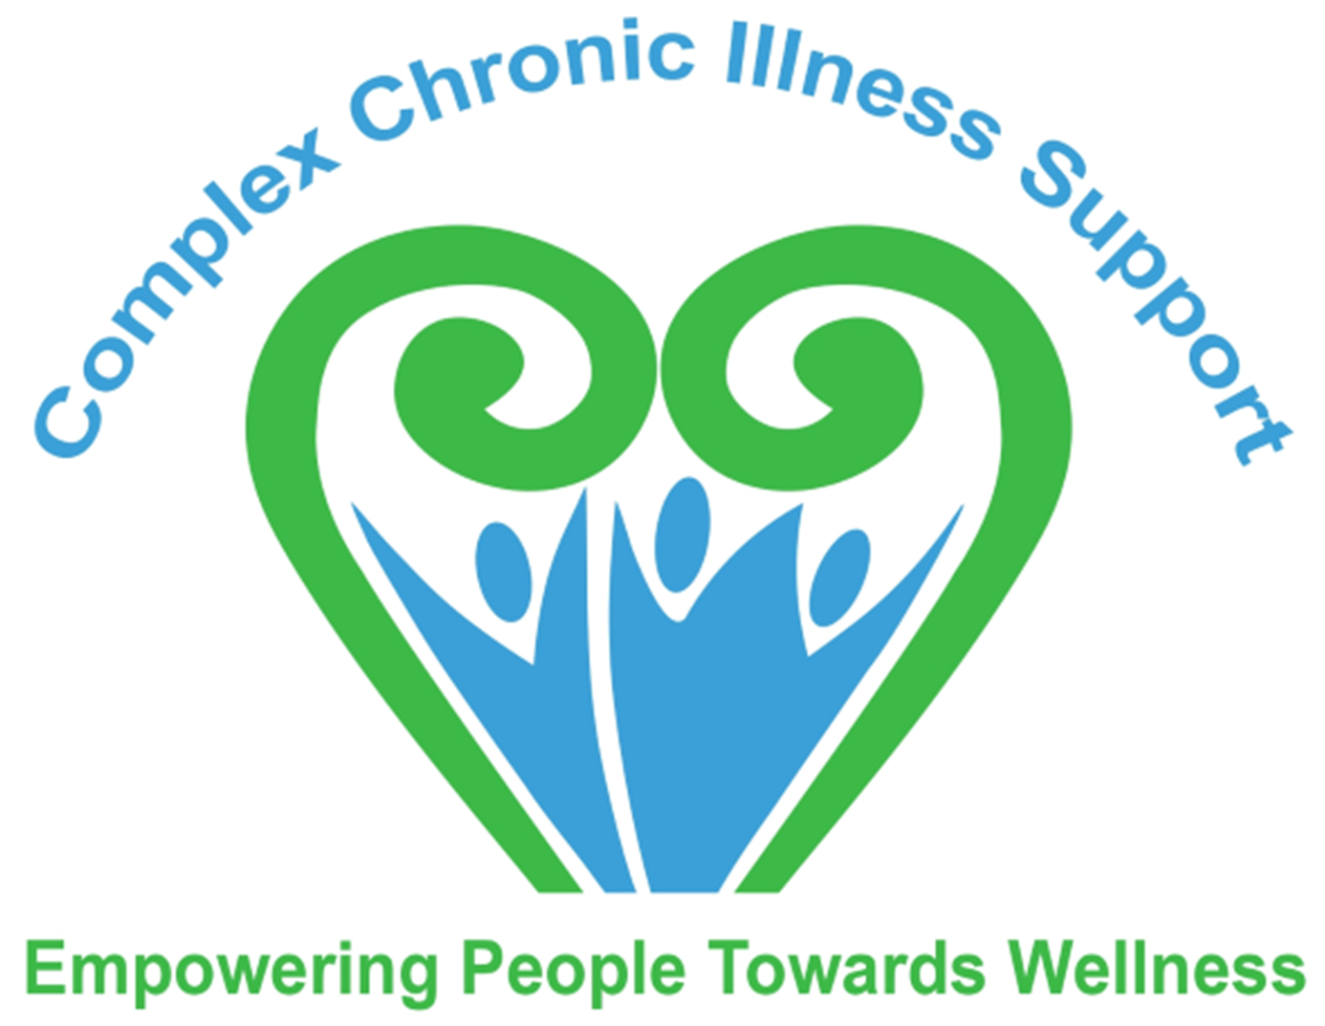

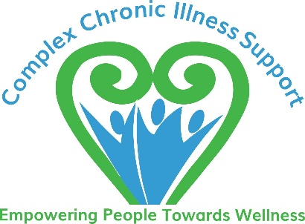ANNUAL GENERAL MEETING

Complex Chronic Illness Support
43 Welcome Bay Road
Welcome Bay
TAURANGA 3112

AGM to be held ONLINE via ZOOM

Saturday 28th October 2023, at 10.30am

AGENDA

- Welcome
- Stand for a moments silence in respect of those members who have passed away since the last AGM
- Present
- Apologies
- Minutes of the 2022 AGM
- Presidents Report
- Financial Report
- Election of Board Members
- Subscriptions for 2024/2025
- Appointment of an Auditor
- Appointment of an honorary Solicitor
- The receipt and consideration of any report, decision or recommendation of the Board or of any other committee.
- Notice of motion and any other motion or matter which the meeting may decide to consider.
- Closure of the Meeting.

